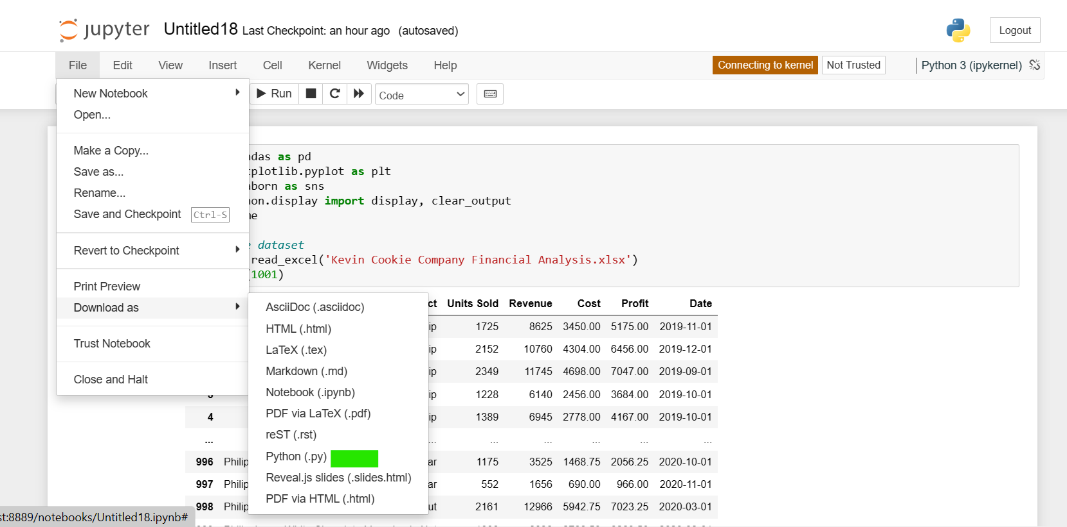

Steps to see the Dashboard on Streamlit via Jupyter Notebook

Step 1: name the file as “Untitled 18” then click save and checkpoint.

After that click “file” icon on the top left and then browse to “Download as”, then navigate to Python (.py) the file will be downloaded as a Python file.

Step 2: After that go to homepage of Jupyter notebook, where we get new files. Click “upload” section on the top right next to “new”. Upload the Untitled 18 file from the download section.

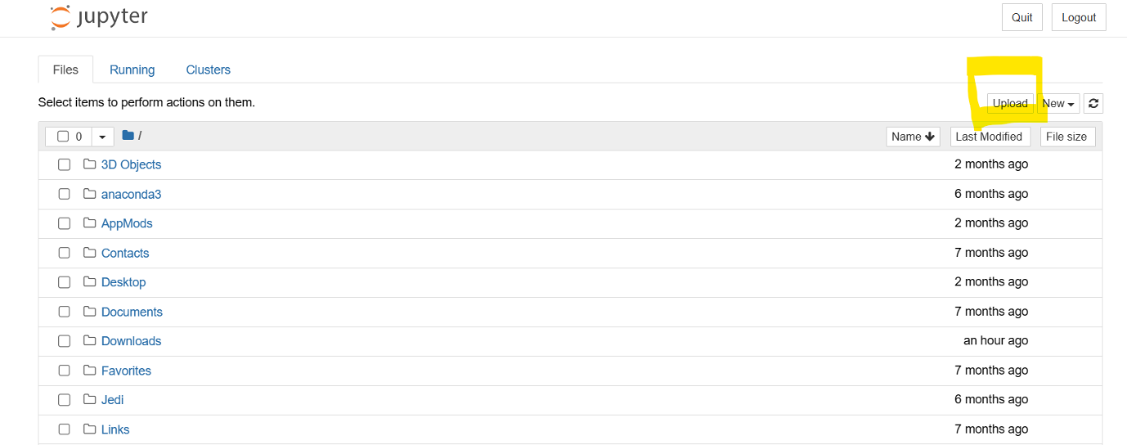

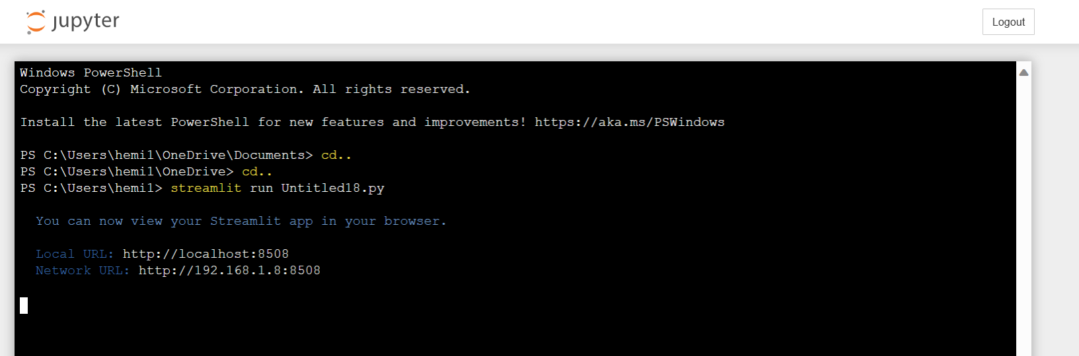

Step 3: Go to terminal. This can be done by going to “new” right of upload and selecting terminal.

Then enter cd.. twice

Then finally run “streamlit run Untitled18.py” as written above

It will direct you to the streamlit dashboard and also gives you the network url as well.

This is a glimpse of how the dashboard will look:

You can use the bar on the left to toggle with the data to make the dashboard interactive.

